Terraform normal ec2 creation

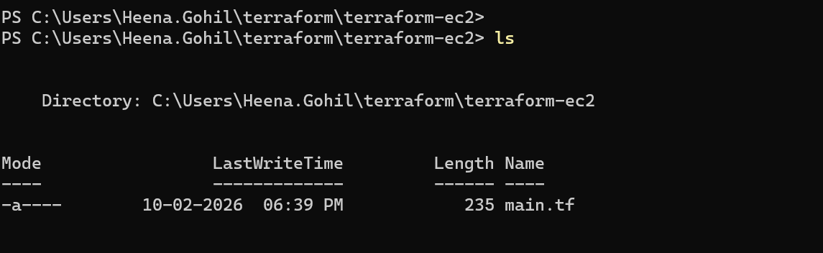

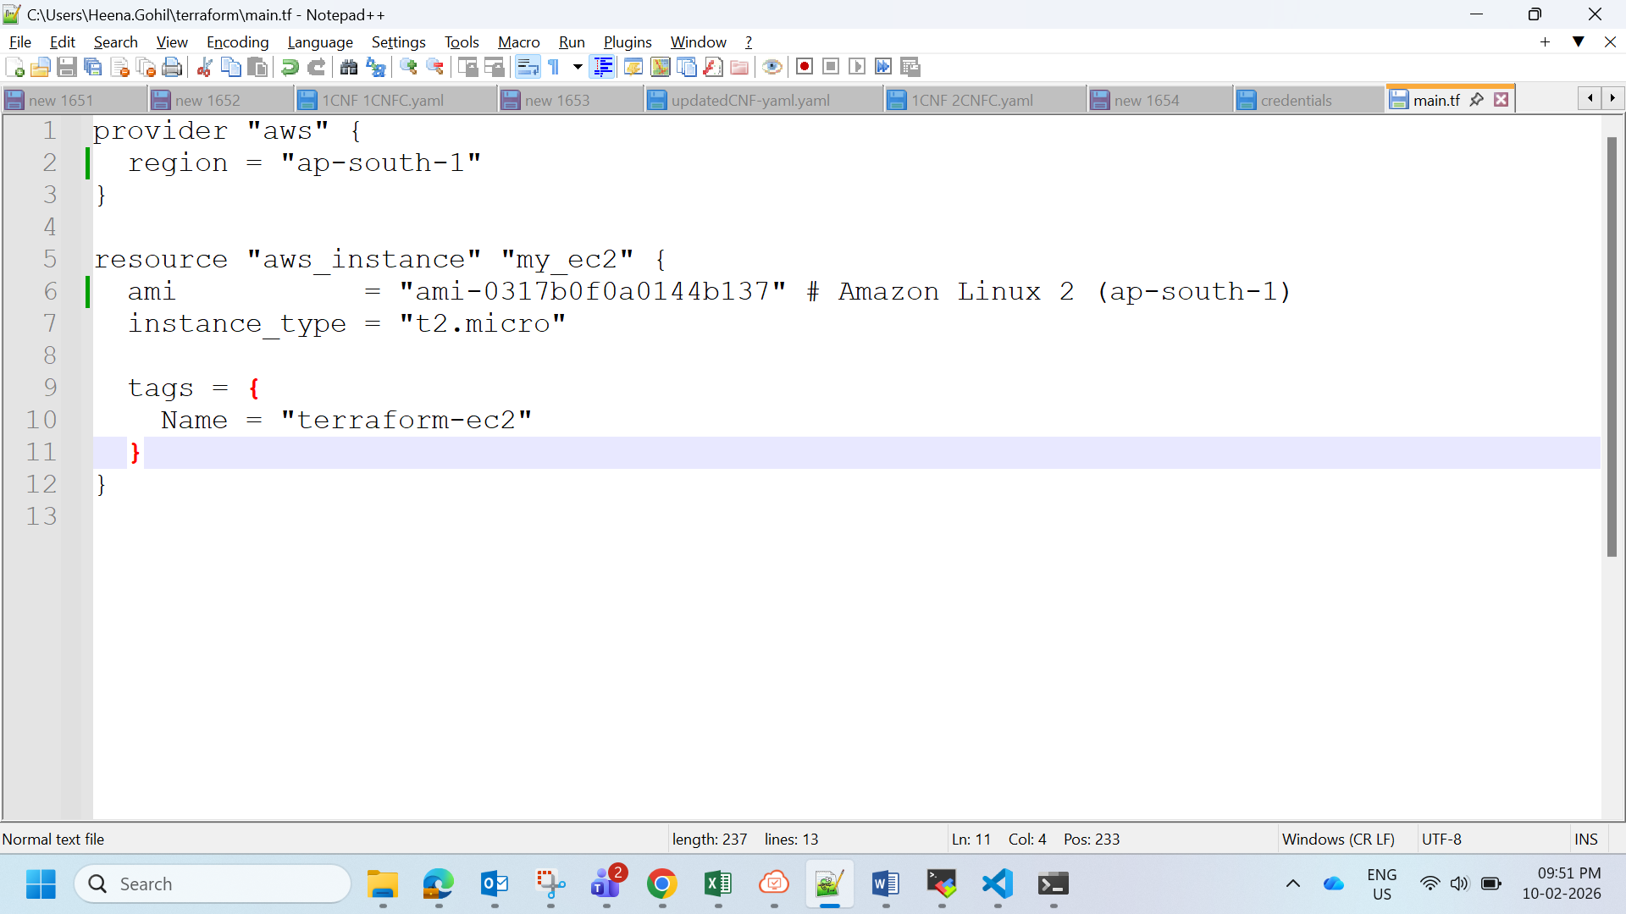

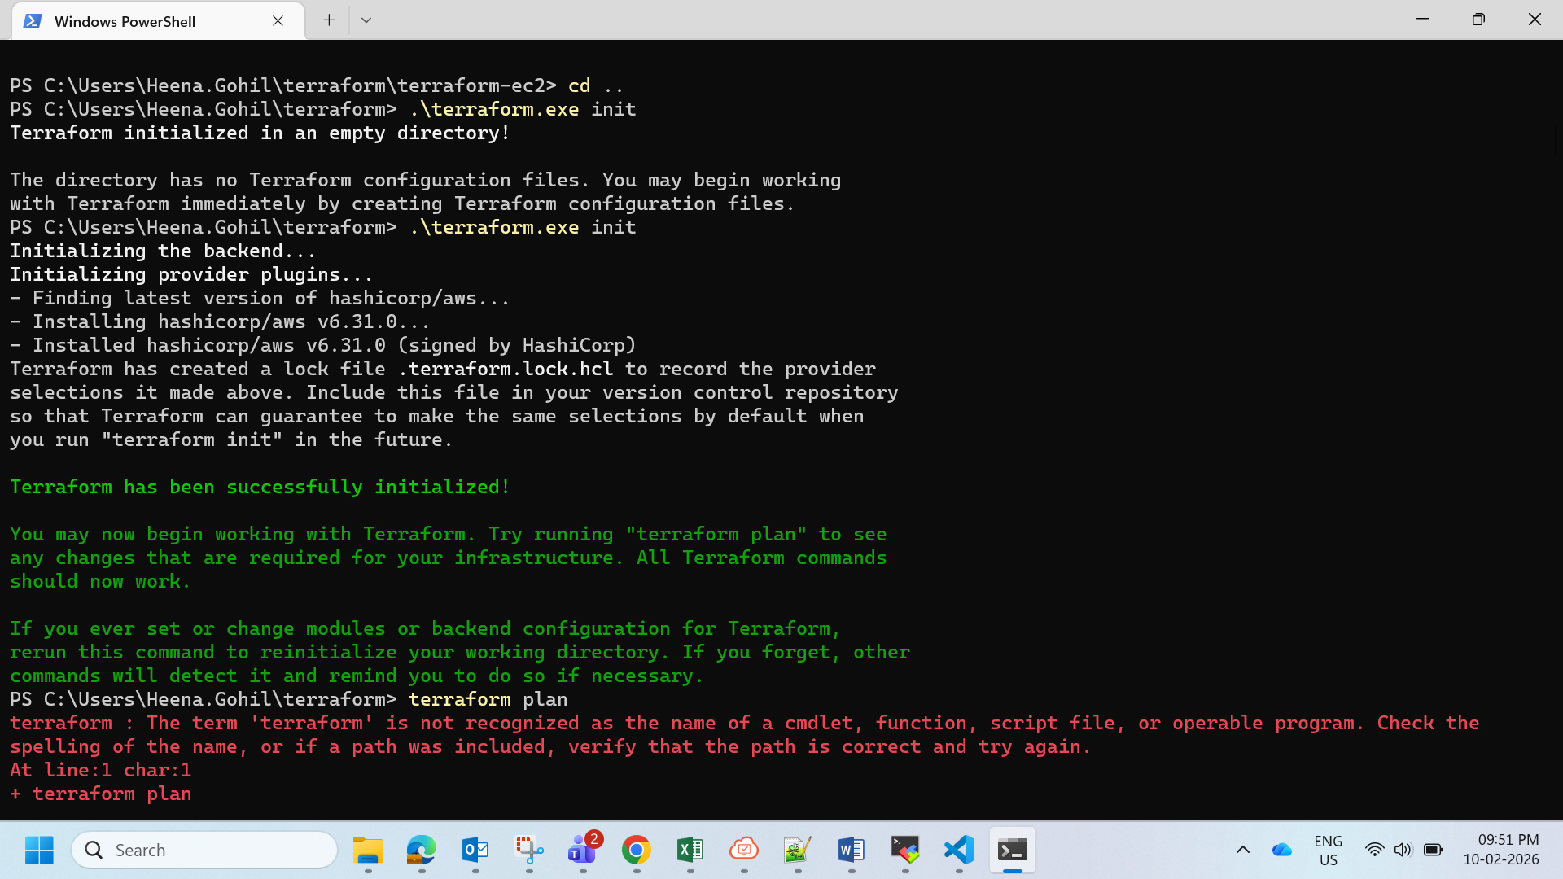

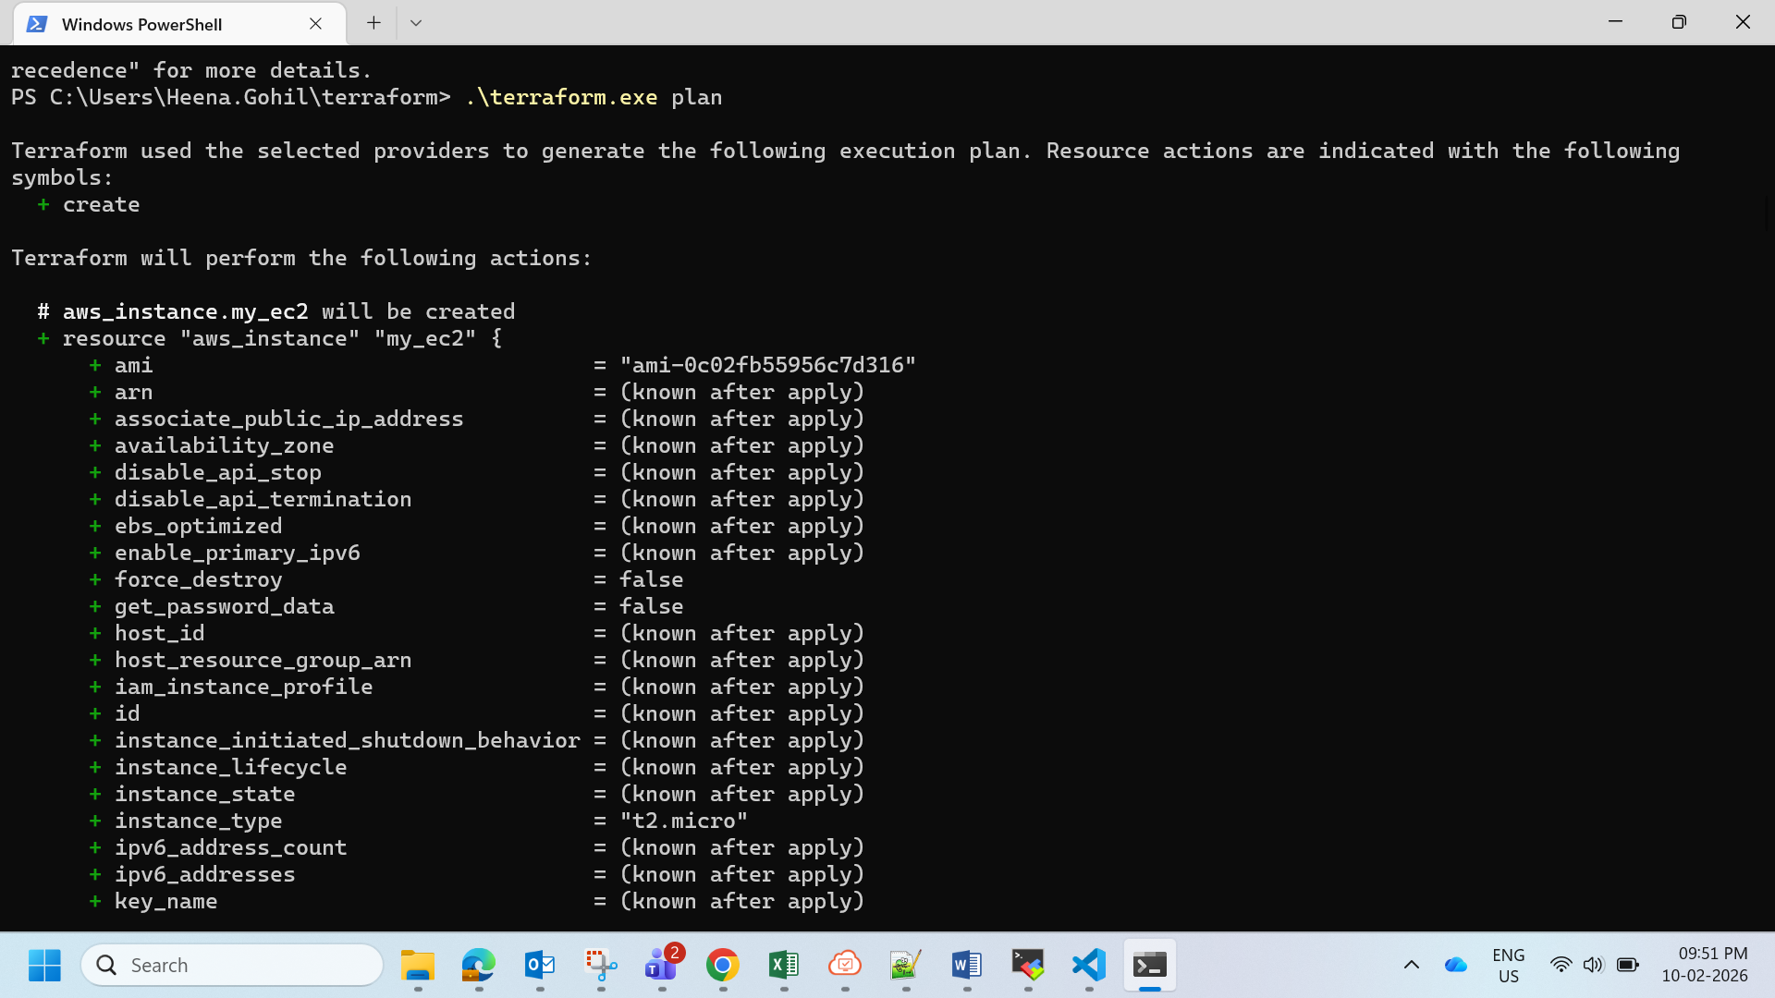

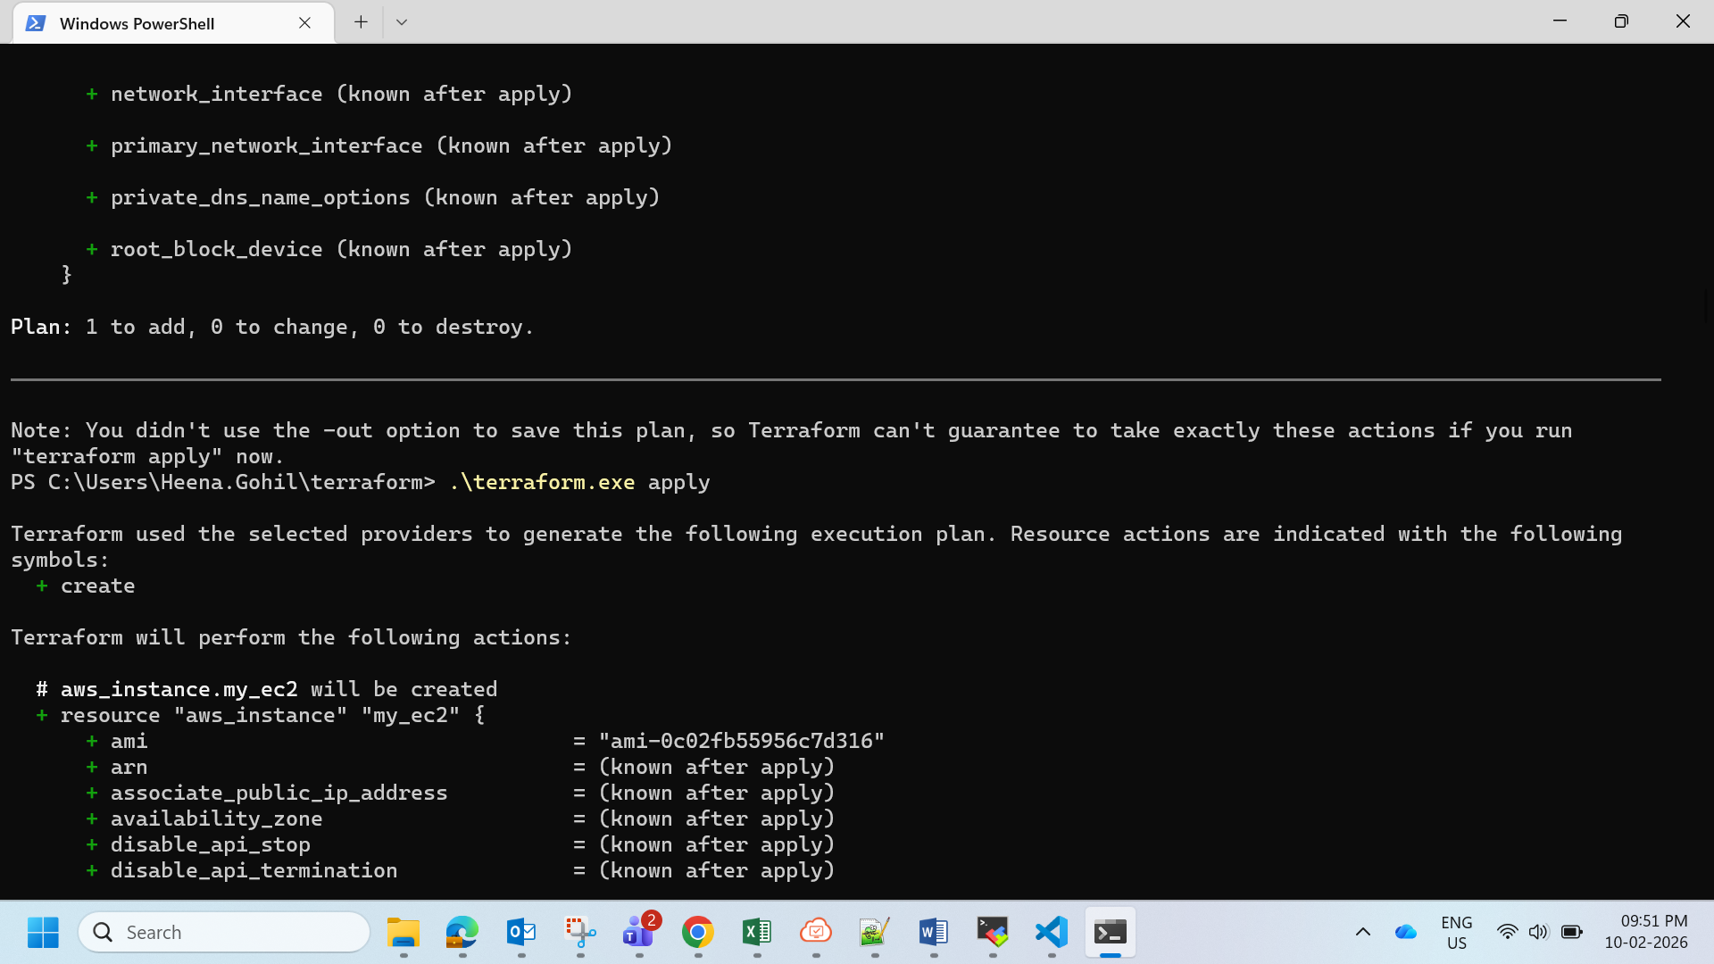

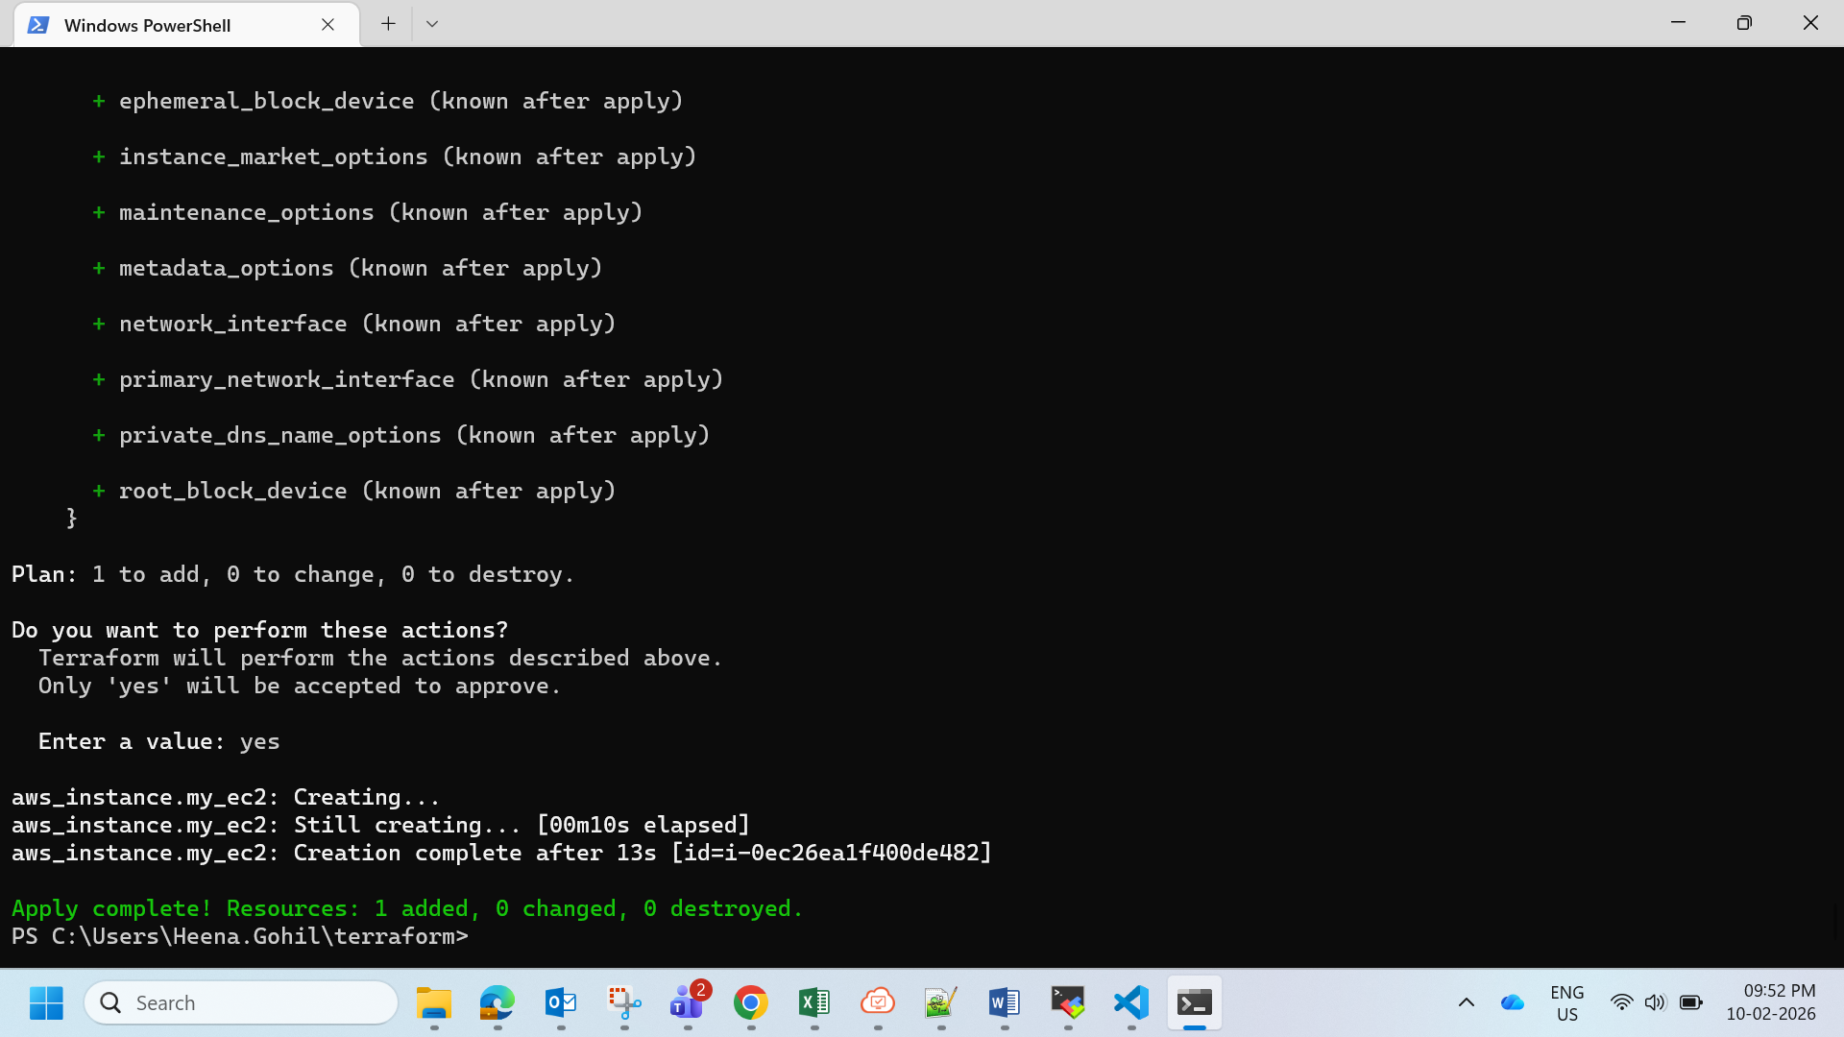

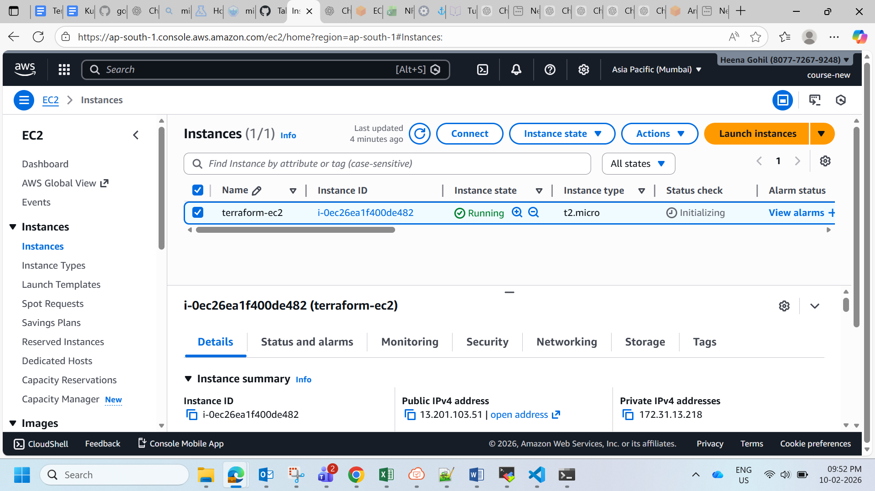

**Part 1: Deploy Both Flask and Express on a Single EC2 Instance**

1. **Objective**: Deploy both the Flask backend and the Express frontend on a **single EC2 instance** using Terraform.
   * Provision the EC2 instance with Terraform.
   * Configure the instance with:
     + A user data script or a configuration management tool (e.g., Ansible or Cloud-Init) to install dependencies (Python, Node.js).
     + Scripts to start the Flask backend and the Express frontend.
   * Ensure both applications are running on different ports (e.g., Flask on port 5000 and Express on port 3000).
2. **Expected Deliverables**:
   * Terraform configuration files (main.tf, variables.tf, etc.).
   * A working EC2 instance with Flask and Express running and accessible via the instance's public IP.

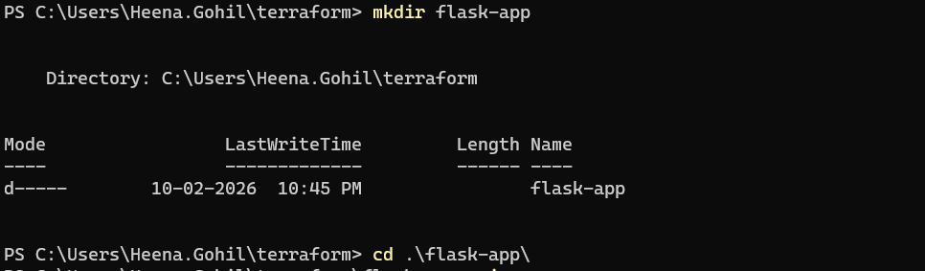

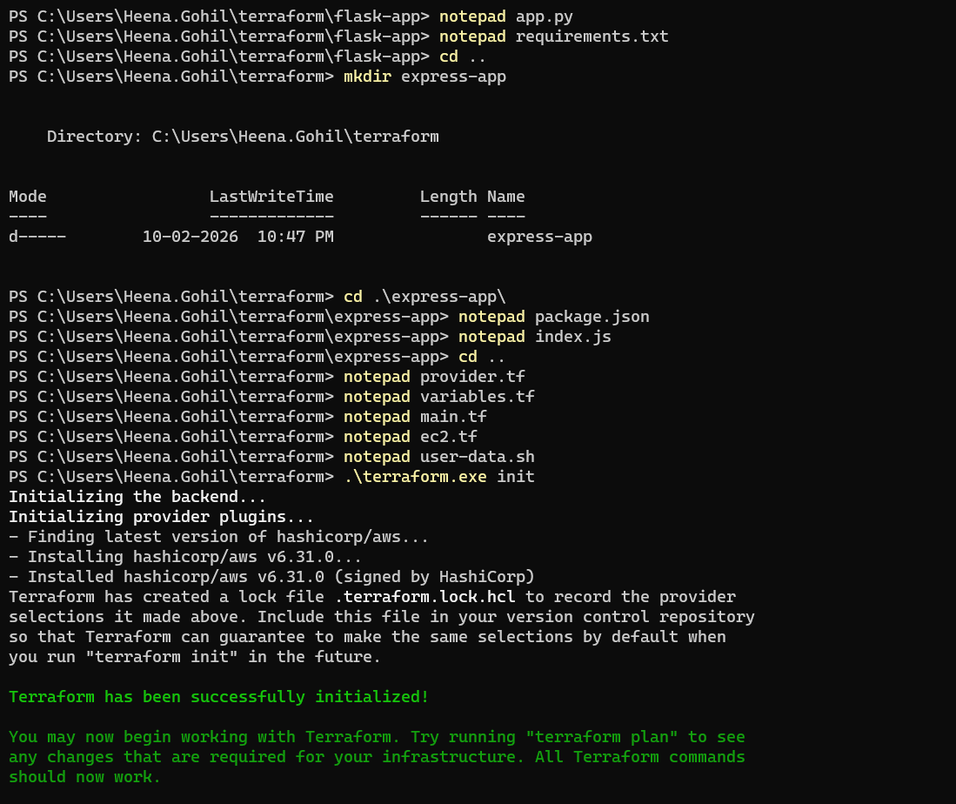

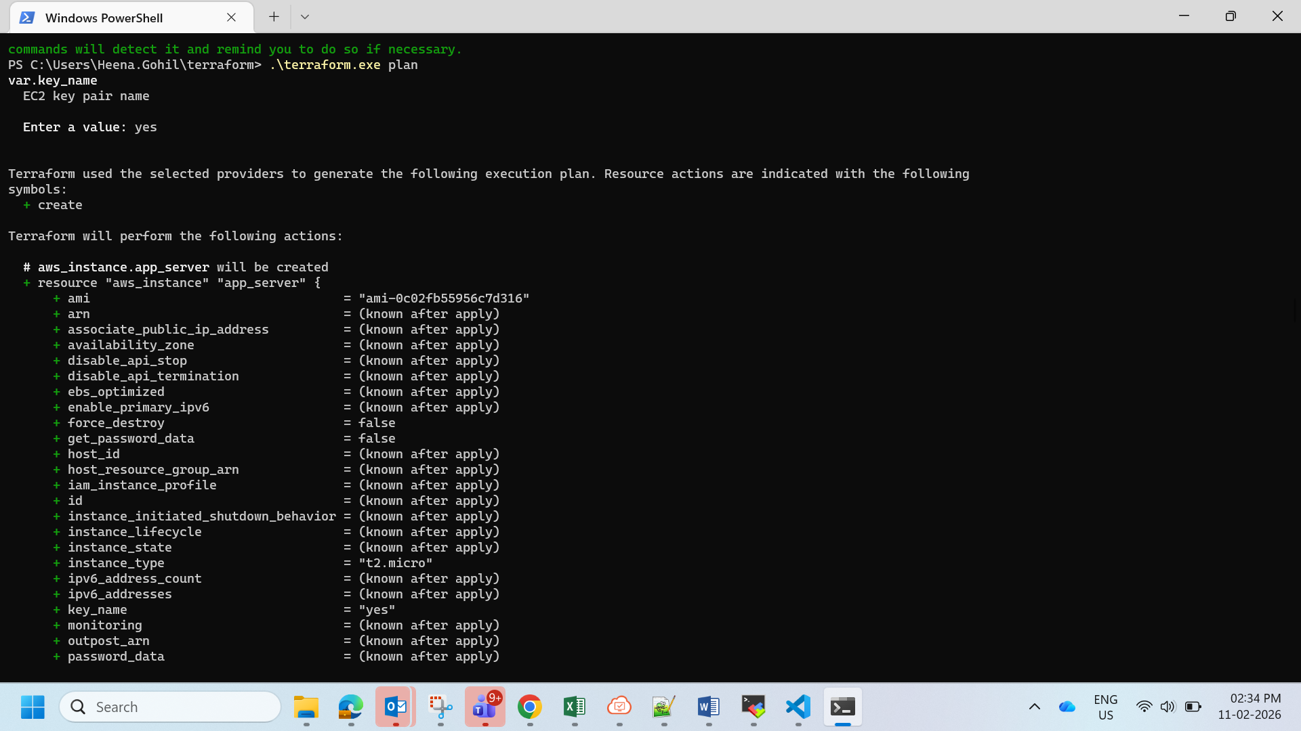

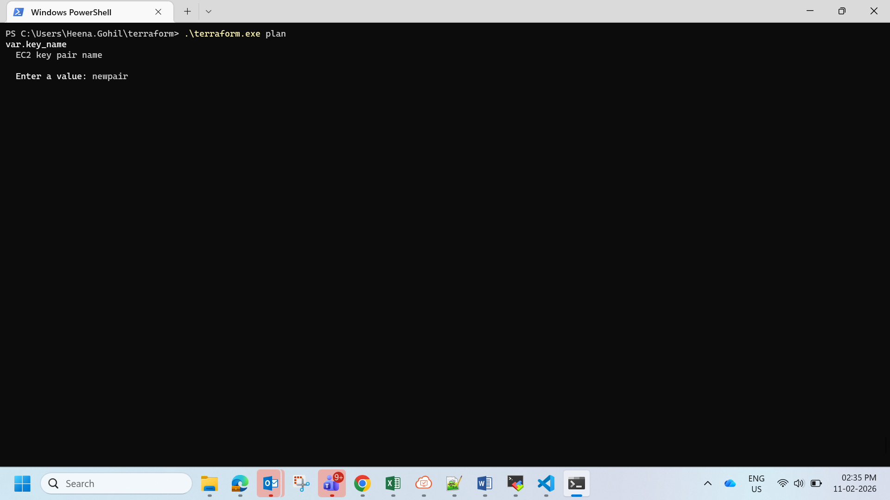

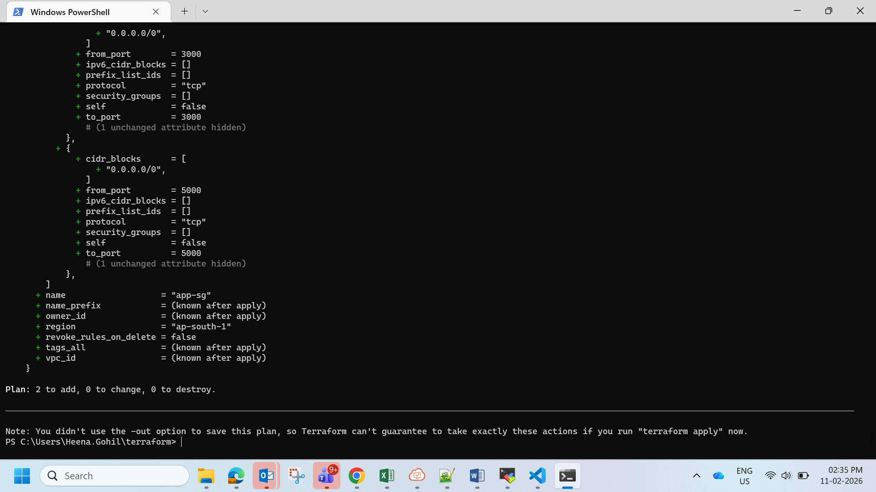

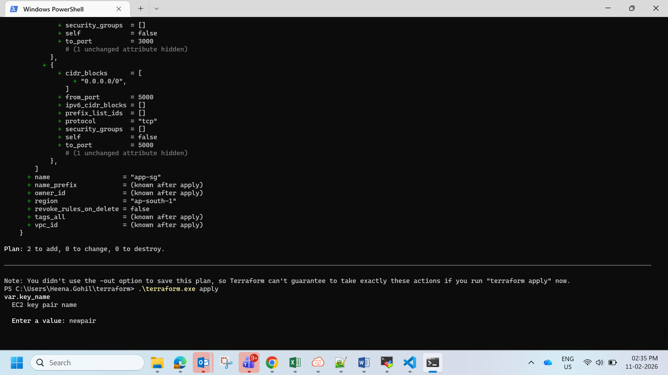

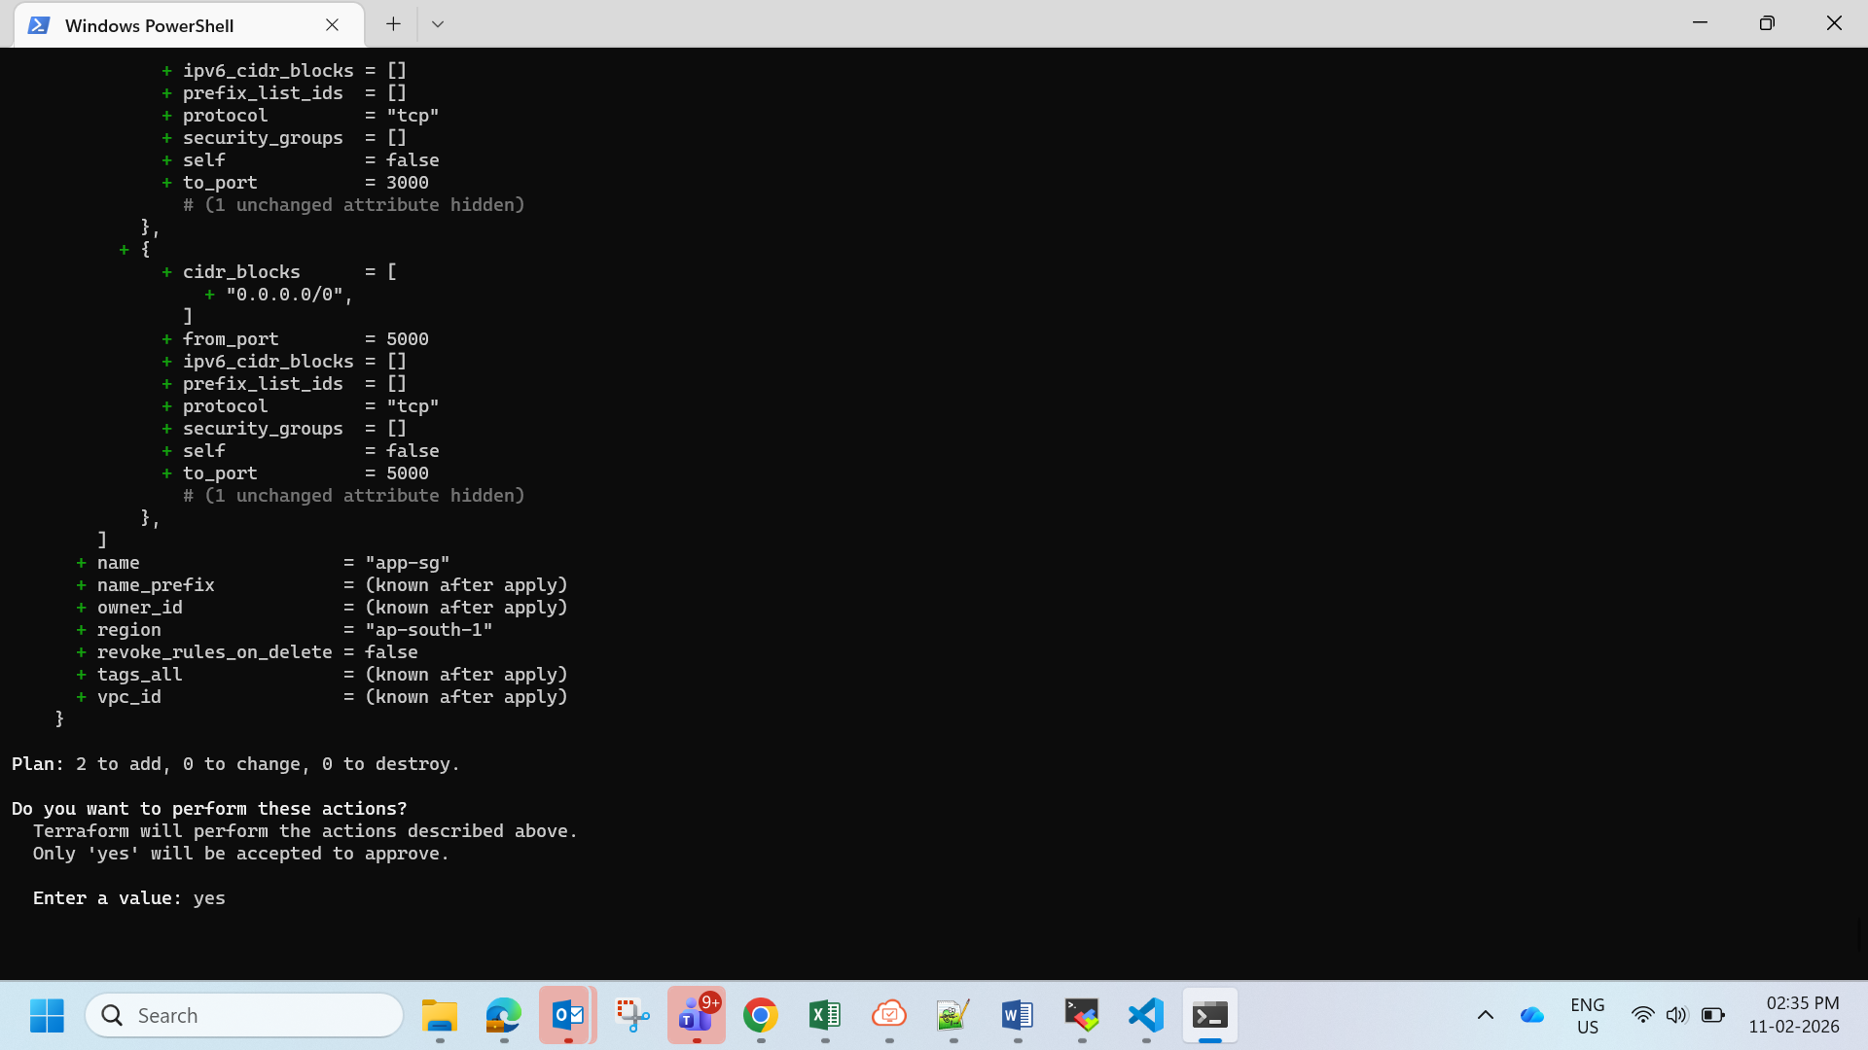

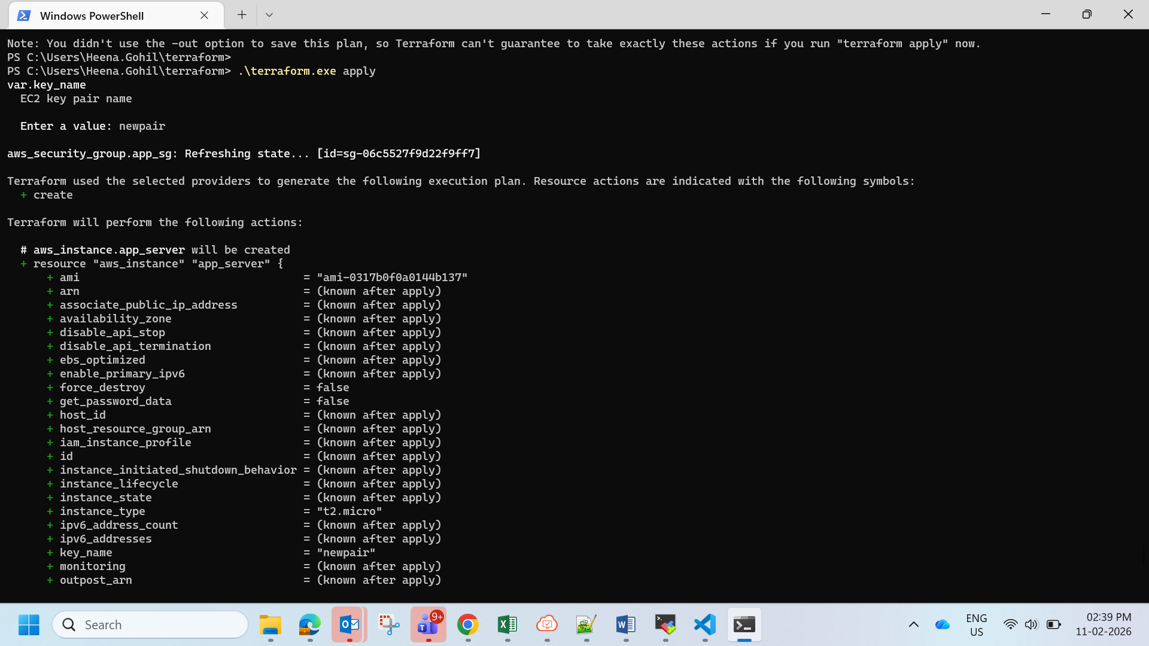

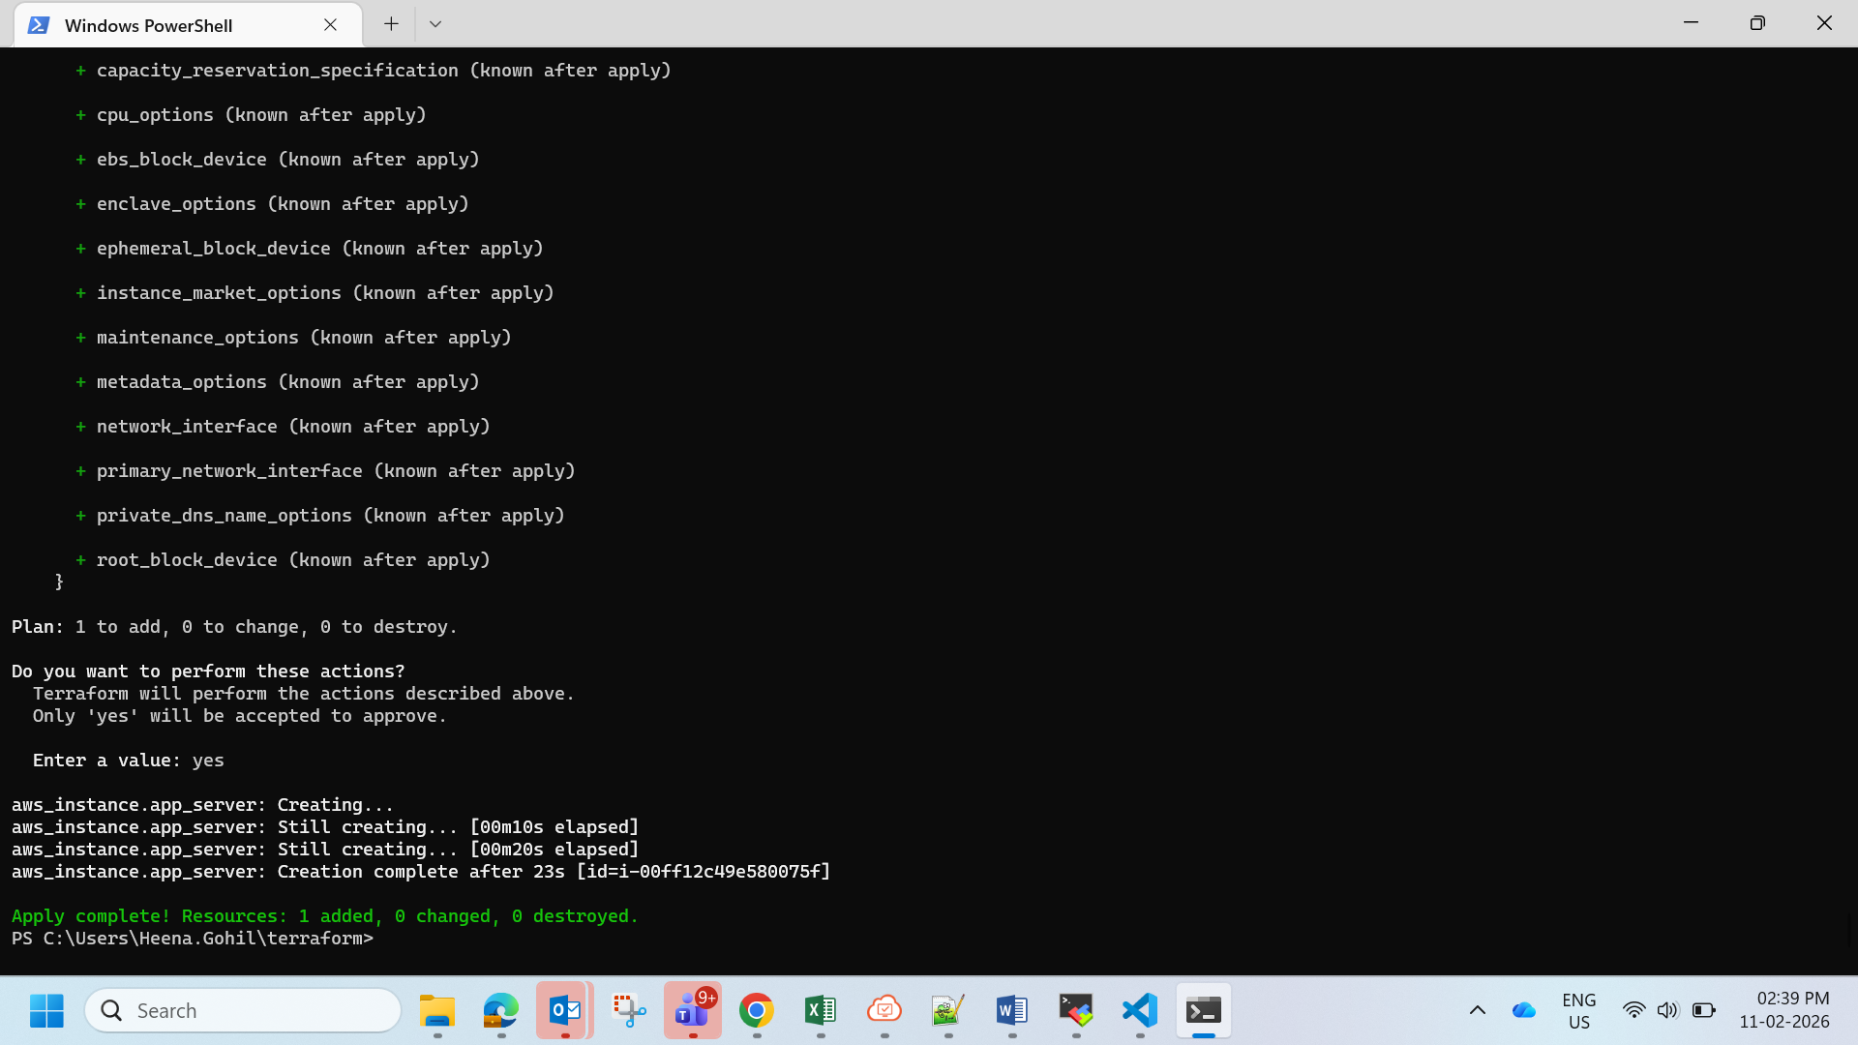

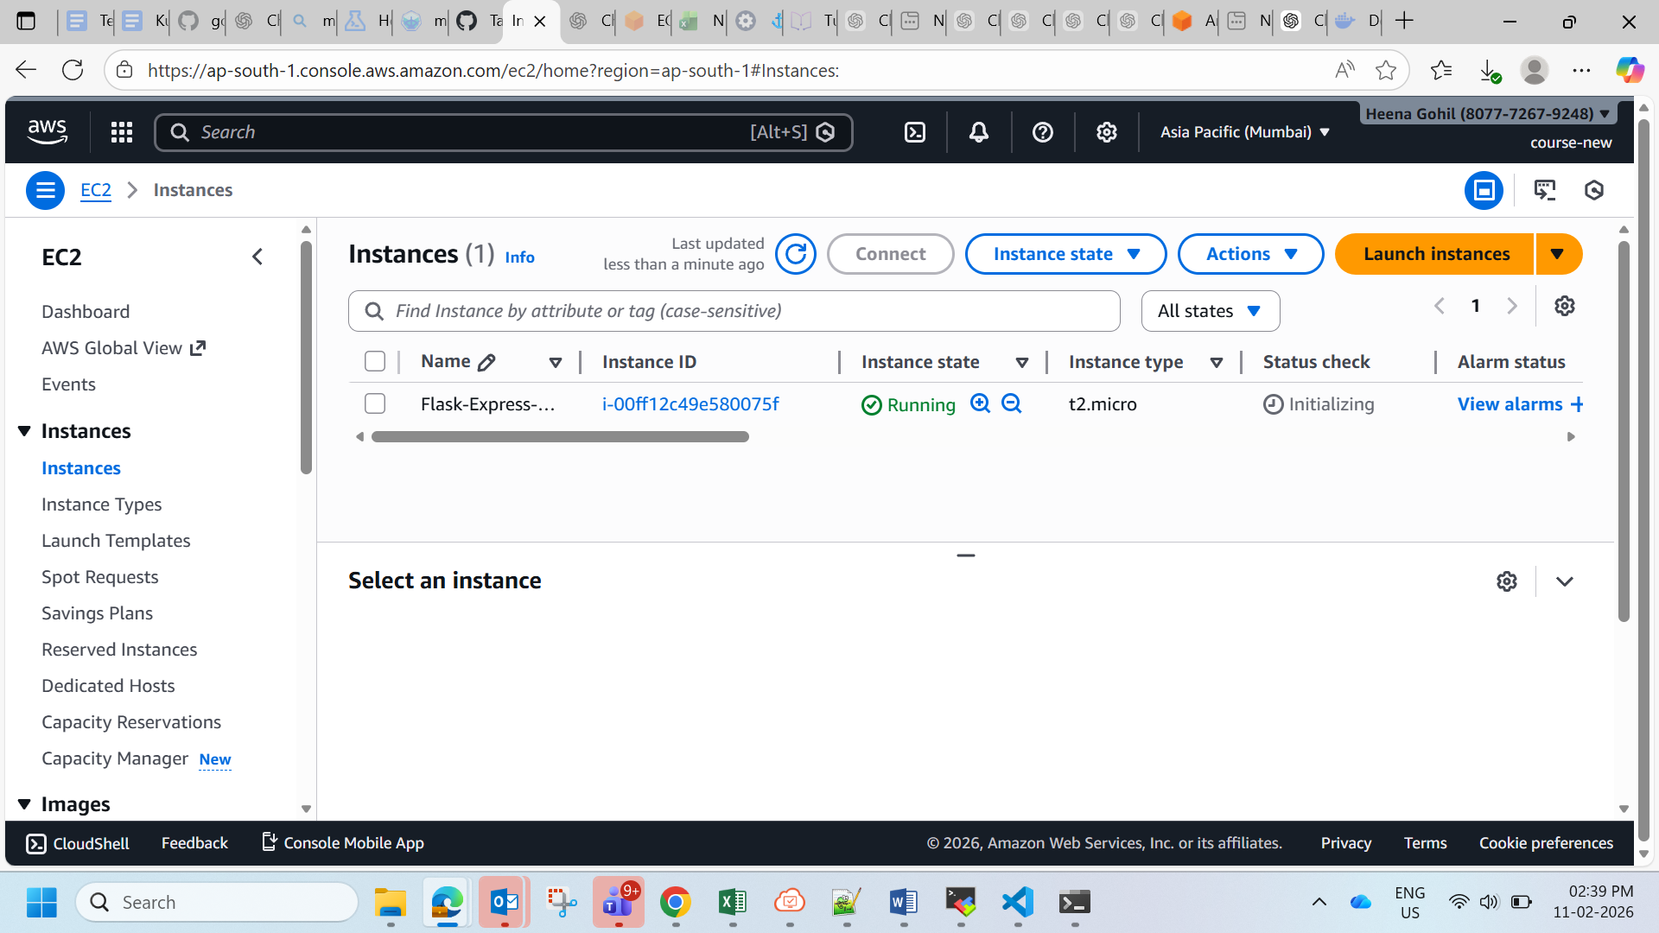

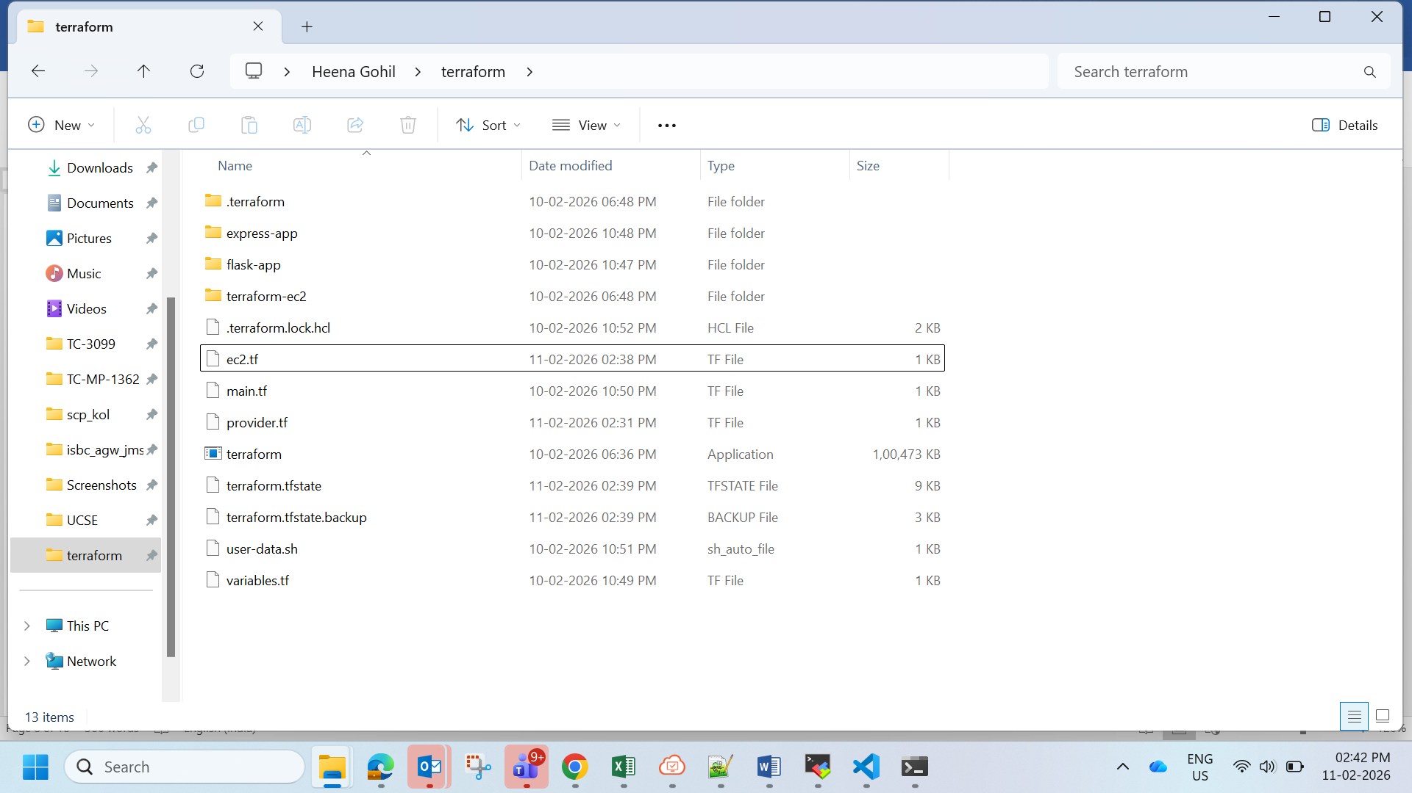

Files

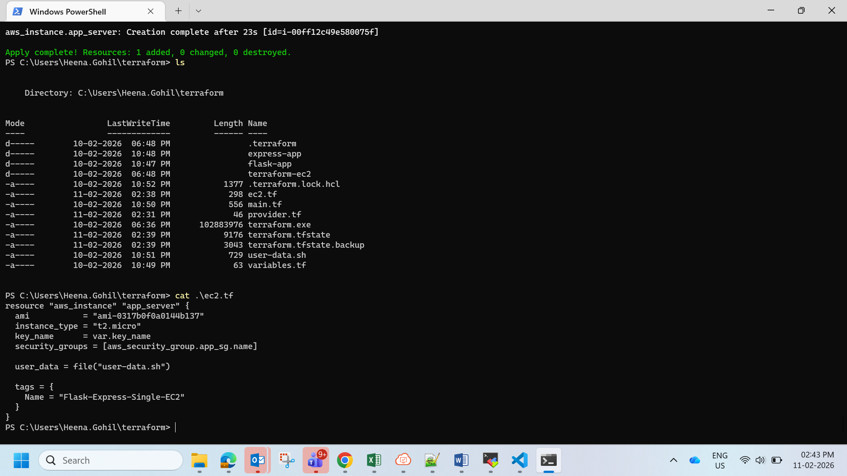

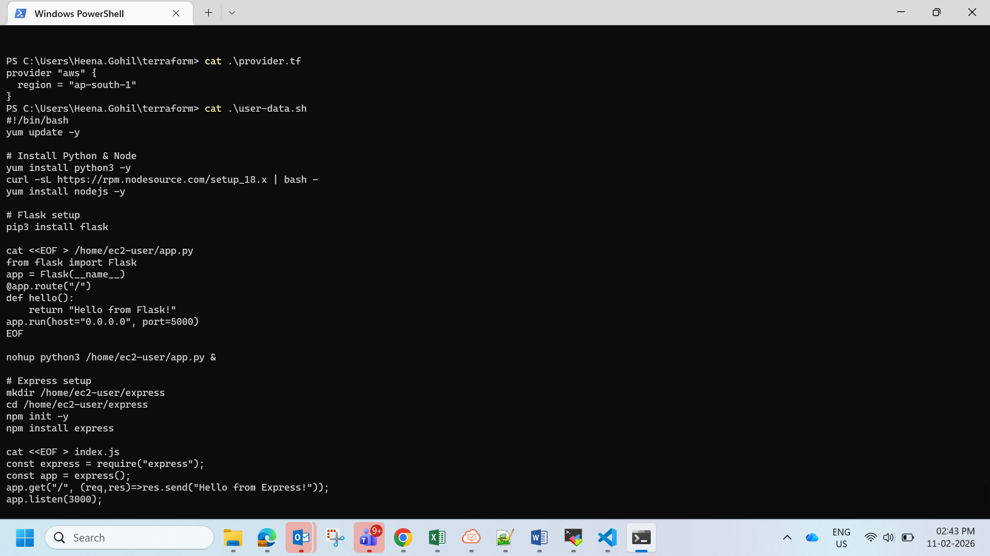

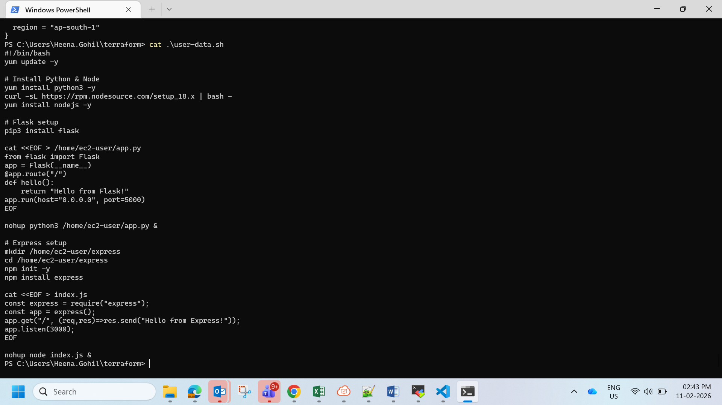

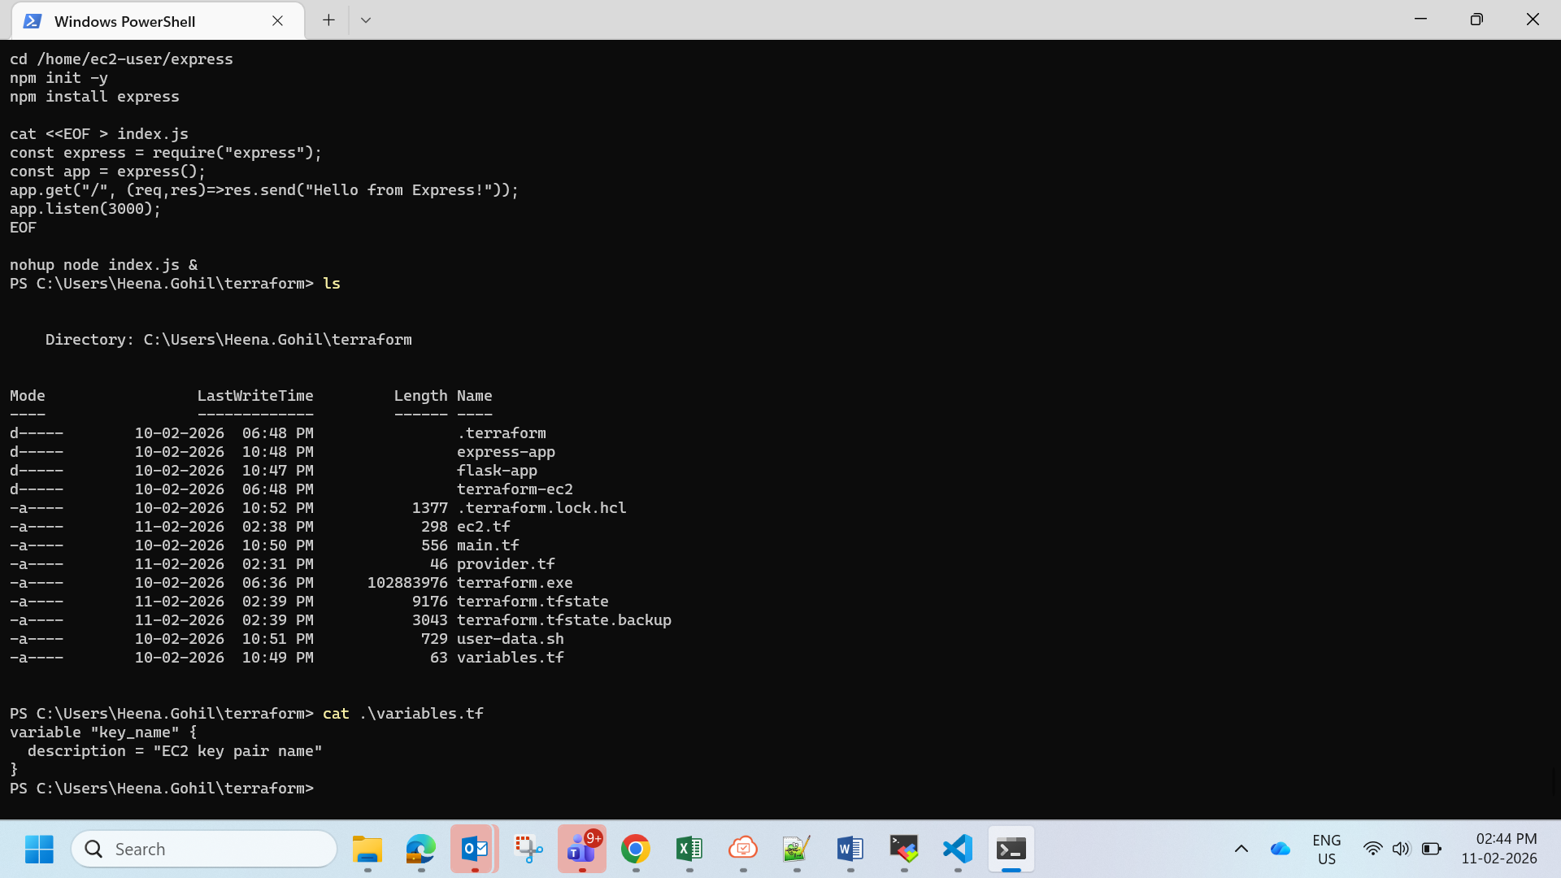

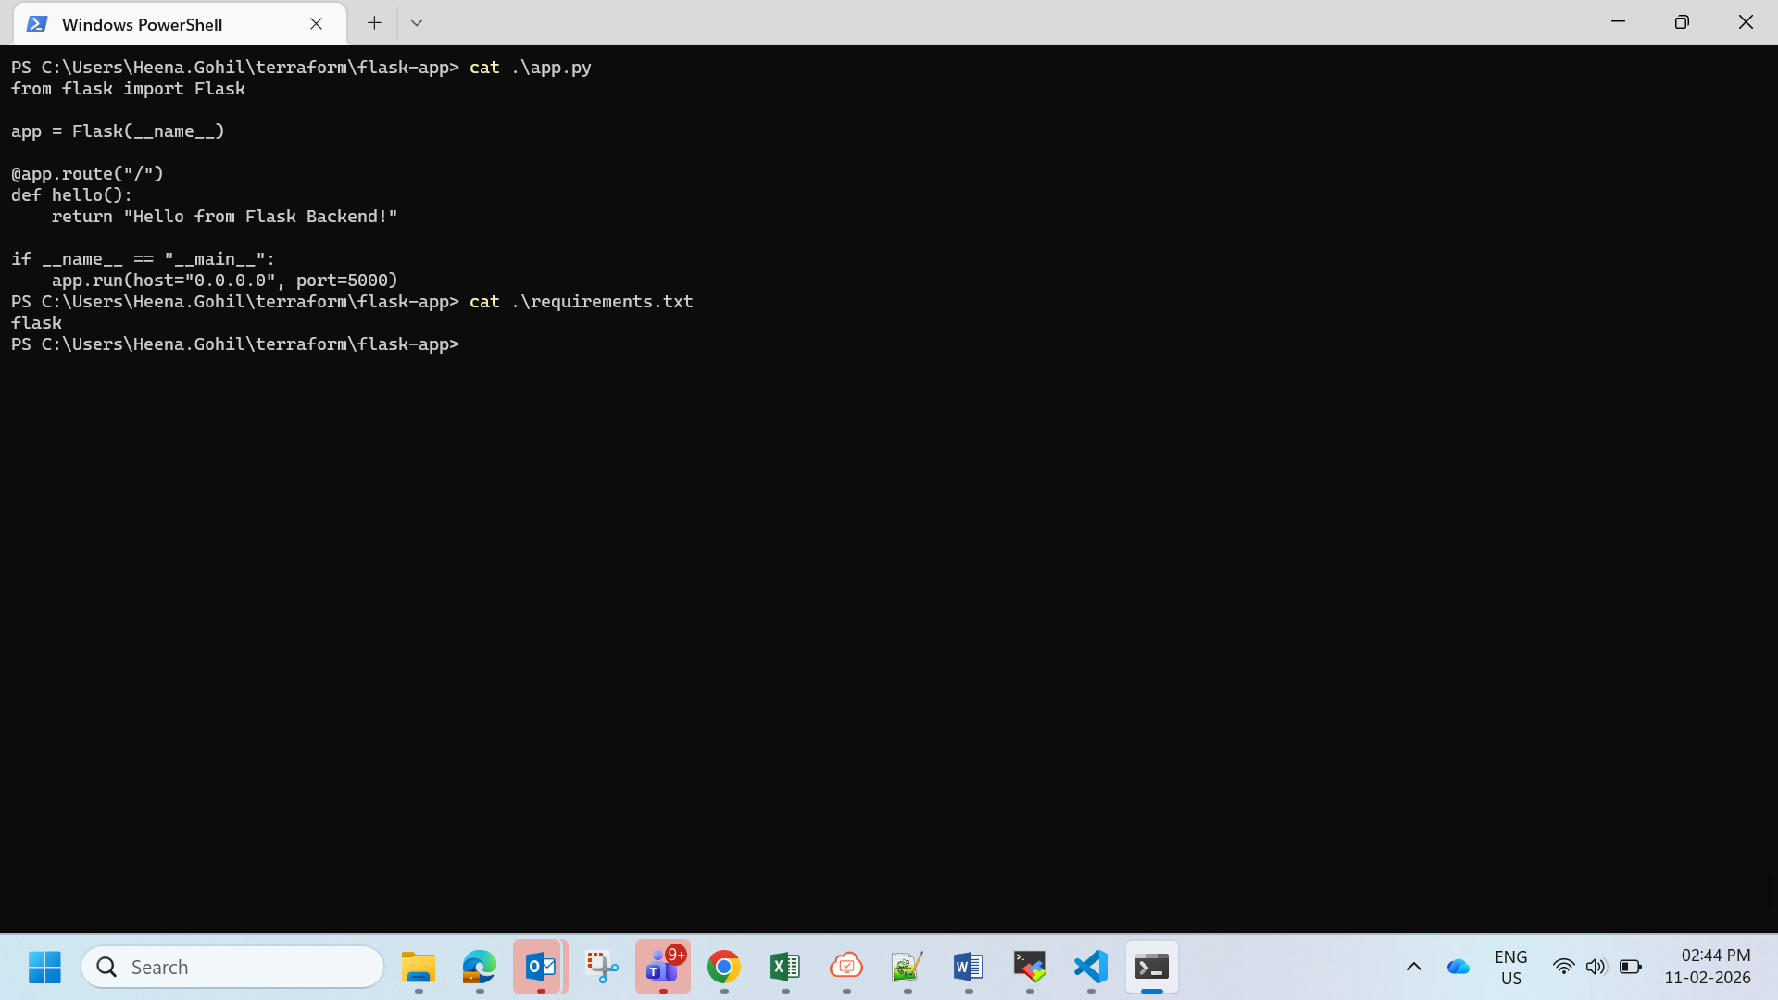

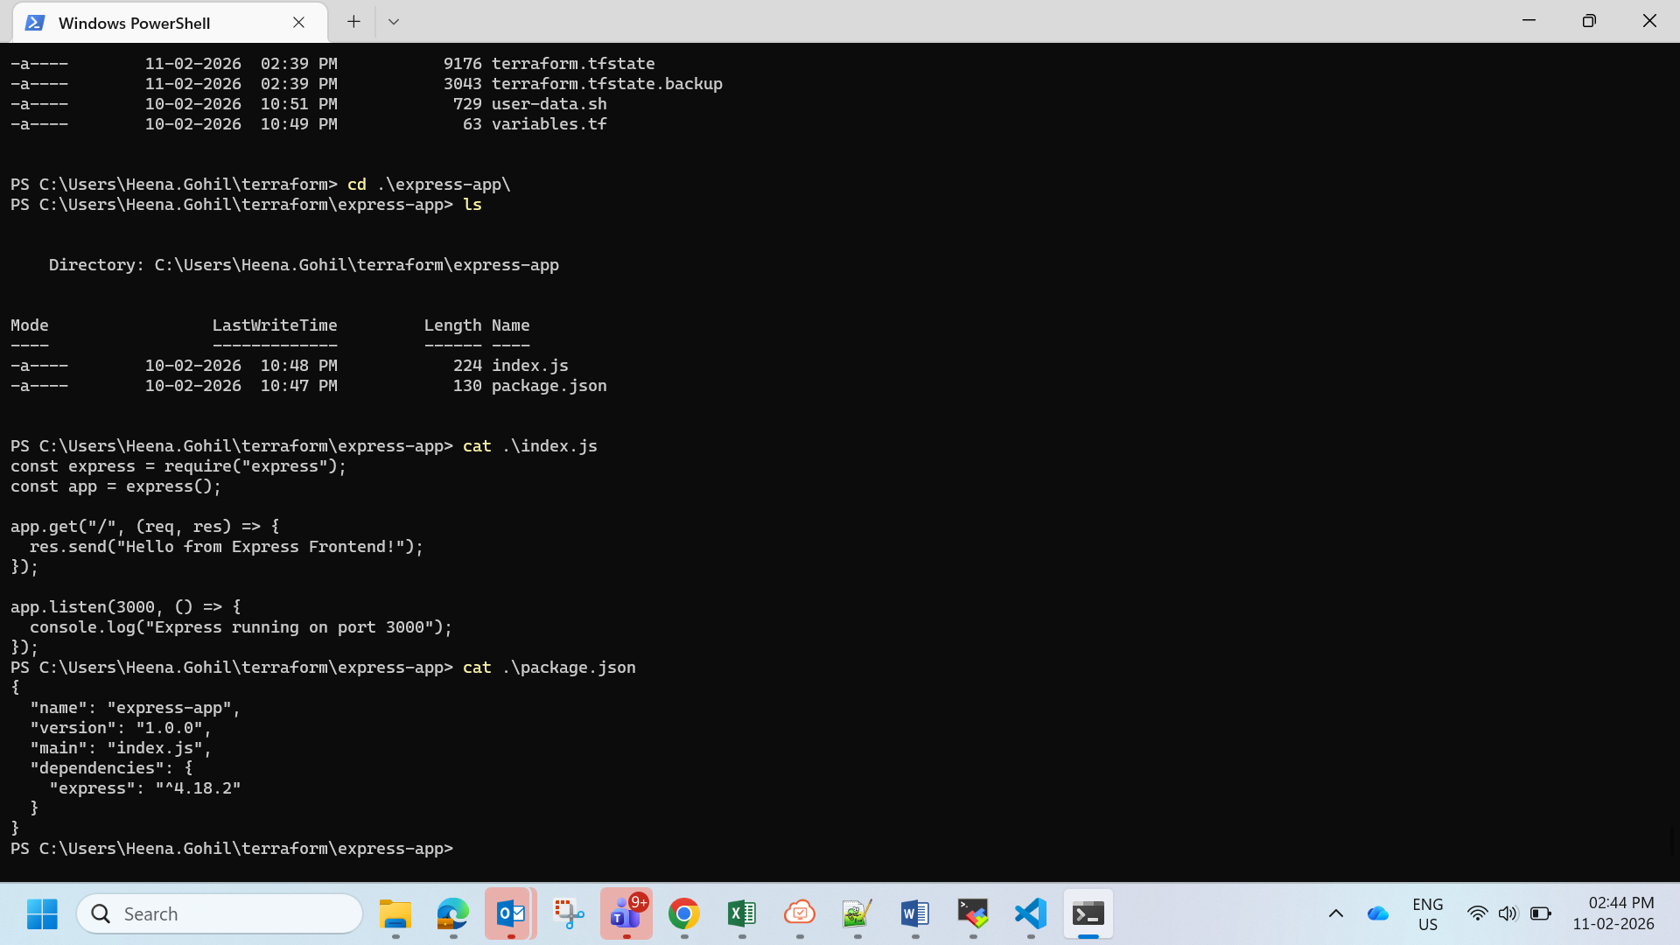

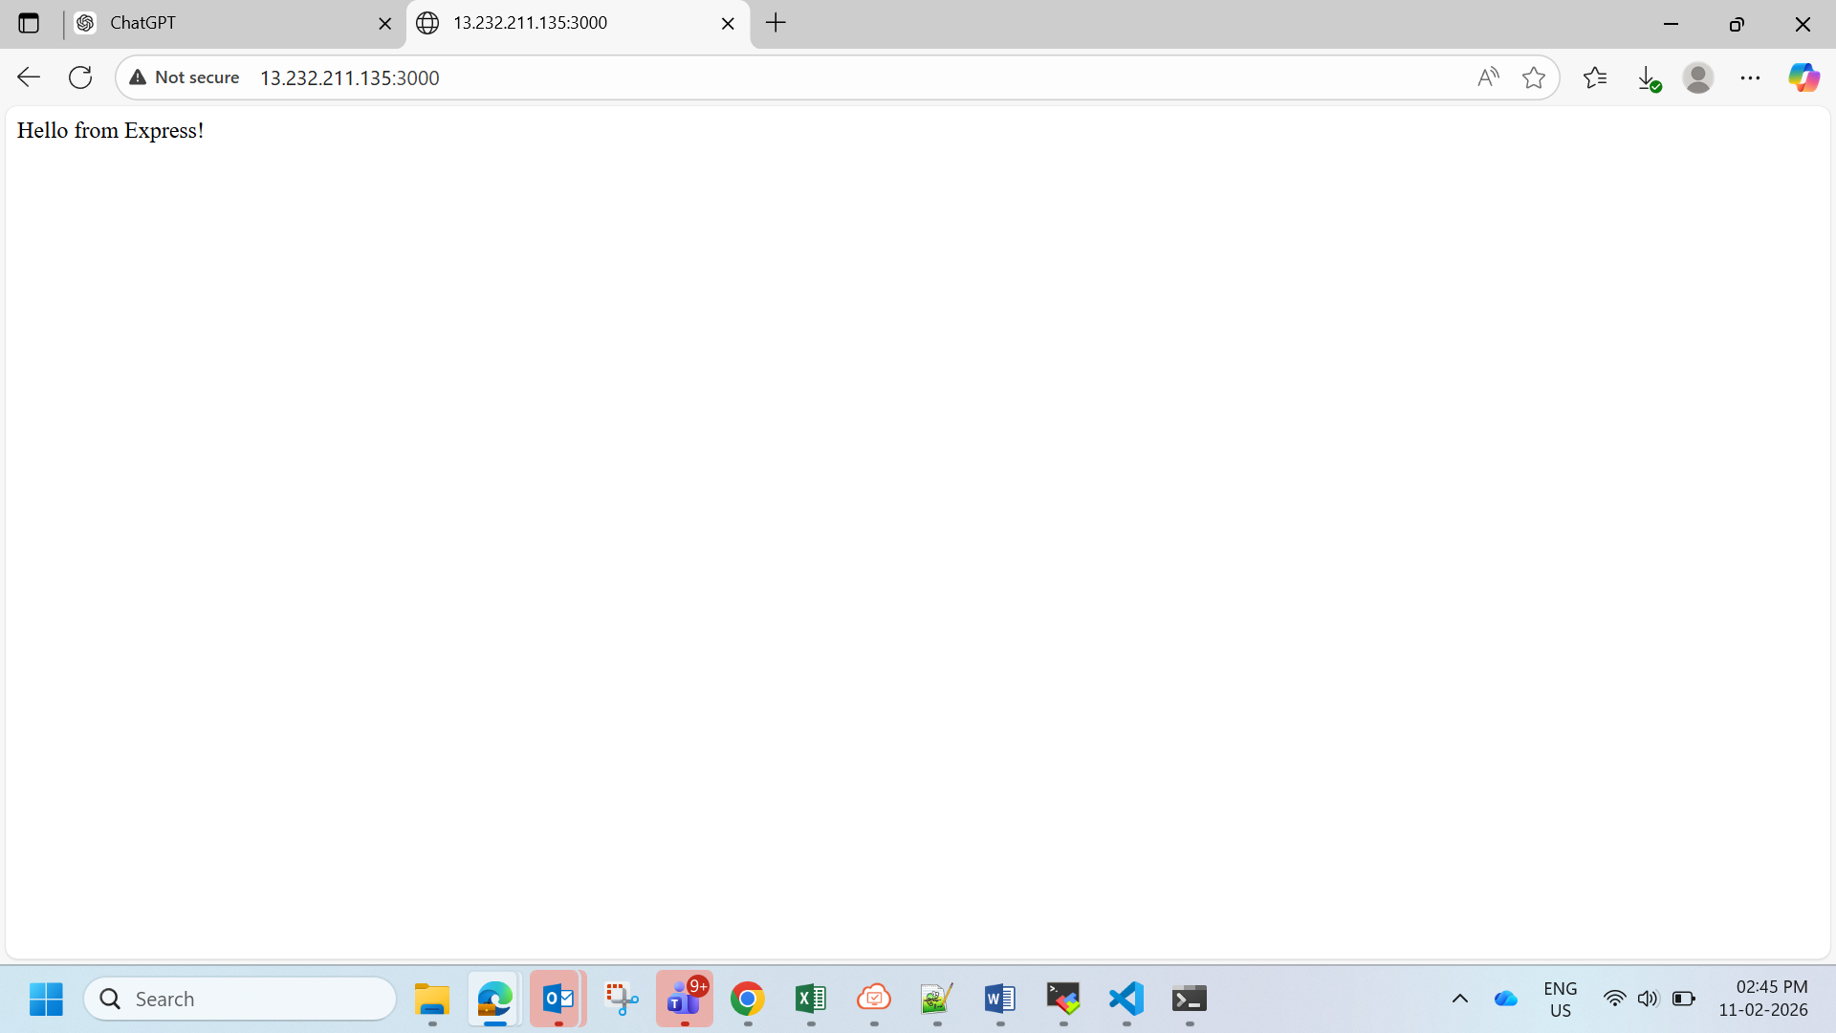

**Part 2: Deploy Flask and Express on Separate EC2 Instances**

1. **Objective**: Deploy the Flask backend and the Express frontend on **two separate EC2 instances** using Terraform.
   * Provision two EC2 instances using Terraform:
     + One for the Flask backend.
     + One for the Express frontend.
   * Configure security groups to:
     + Allow communication between the two instances.
     + Expose both applications to the internet on their respective ports.
2. **Configuration**:
   * Use Terraform to define networking resources, such as VPC, subnets, and security groups.
   * Use user data scripts to automate the installation and startup of both applications.
3. **Expected Deliverables**:
   * Terraform configuration files.
   * Two working EC2 instances: one running Flask and one running Express.
   * Security groups configured to allow proper communication and public access.

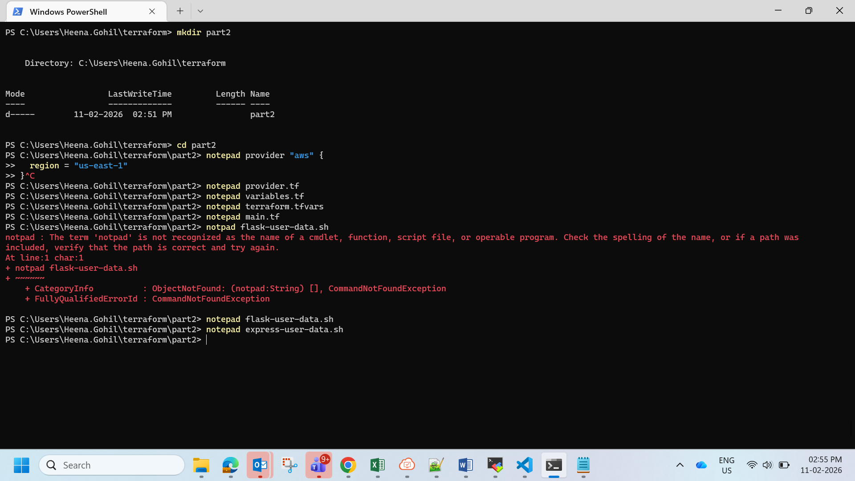



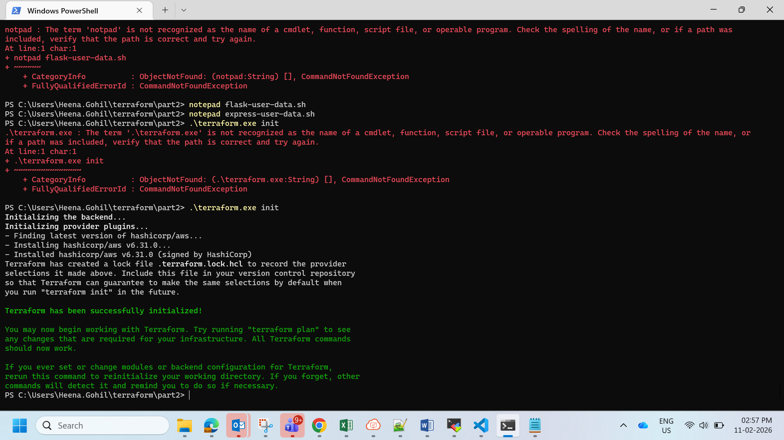

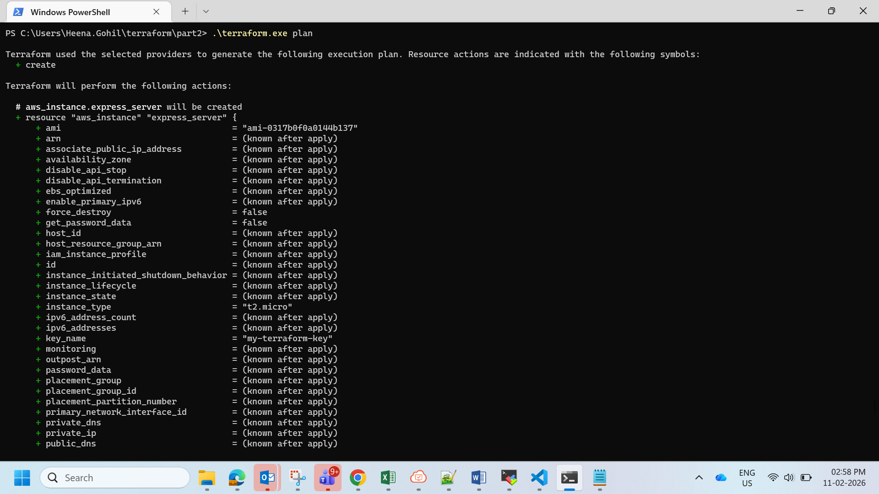

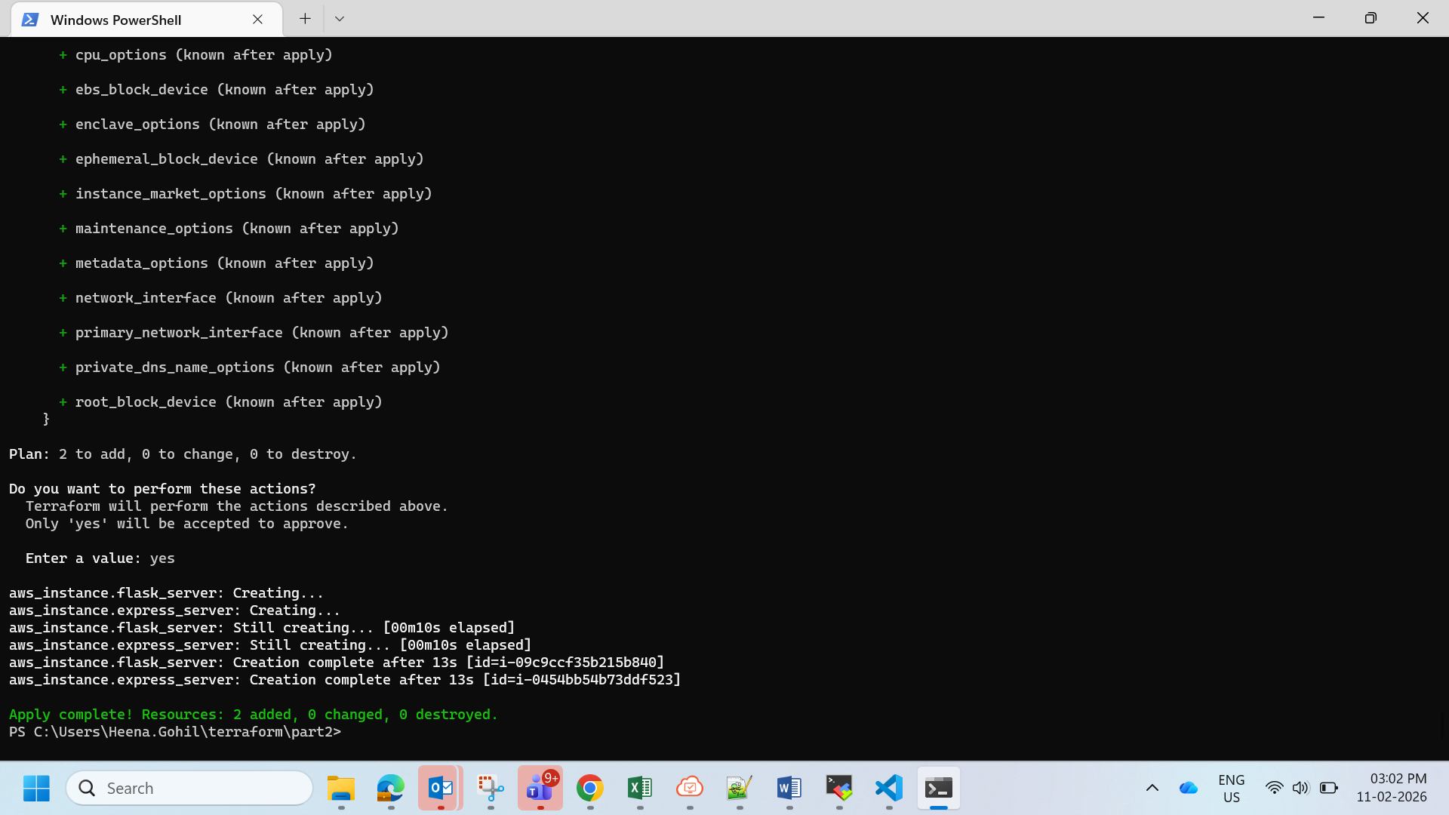

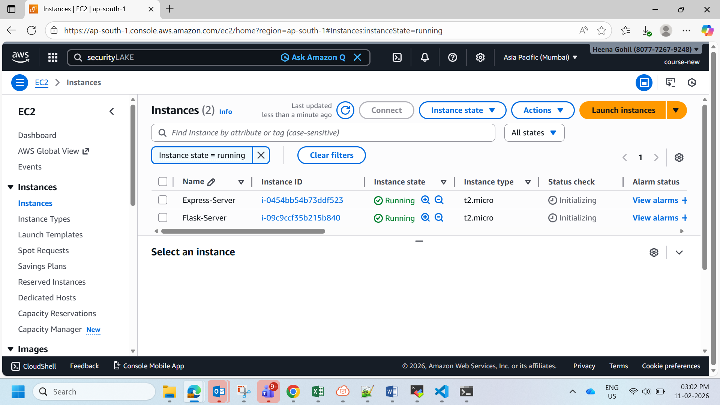

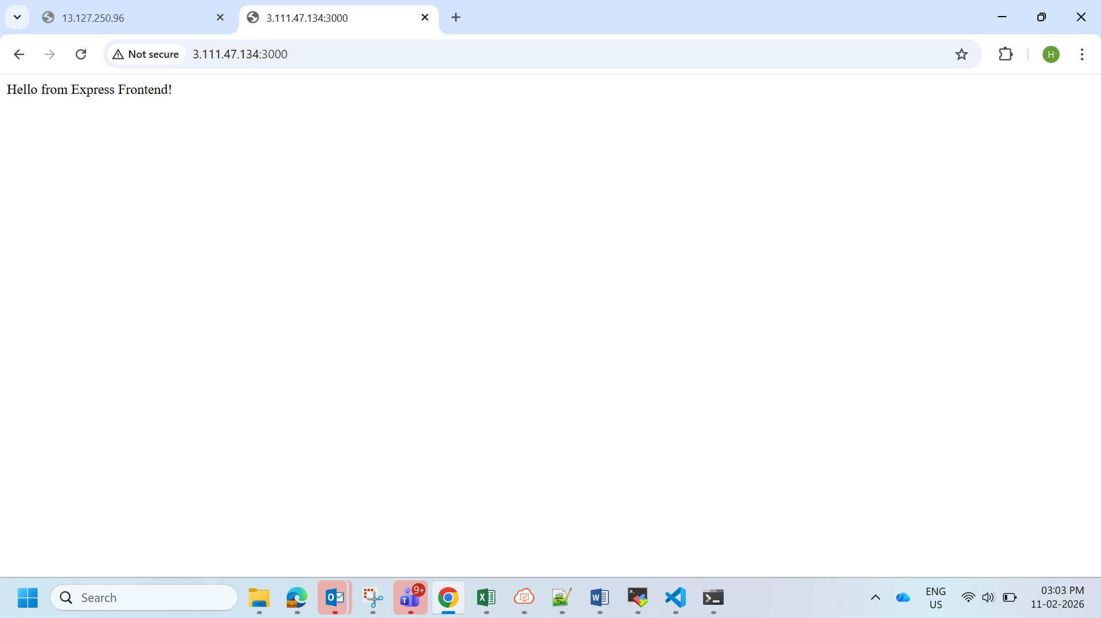

**Part 3: Deploy Flask and Express Using Docker and AWS Services**

1. **Objective**: Deploy Flask and Express as **Docker containers** using **AWS ECR**, **ECS**, and **VPC** with Terraform.
2. **Steps**:
   * **ECR**:
     + Use Terraform to create two Elastic Container Registry (ECR) repositories: one for the Flask backend and one for the Express frontend.
     + Build Docker images for both applications and push them to their respective ECR repositories.
   * **VPC**:
     + Use Terraform to create a VPC with subnets, route tables, and security groups.
   * **ECS**:
     + Use Terraform to set up an ECS cluster.
     + Create two ECS services:
       - One for the Flask backend.
       - One for the Express frontend.
     + Use ECS Fargate or EC2 launch type to deploy the containers.
   * **Load Balancer**:
     + Use Terraform to provision an Application Load Balancer (ALB).
     + Configure ALB listeners to route requests to the appropriate ECS service.
3. **Expected Deliverables**:
   * Terraform configuration files for ECR, ECS, VPC, and ALB setup.
   * Docker images pushed to ECR.
   * ECS services running and accessible via the ALB.

**General Requirements**

* Ensure that all Terraform configurations follow best practices, including the use of variables.tf and outputs.tf.
* Use **Terraform State** (e.g., S3 backend) for state management.
* Use terraform plan and terraform apply to validate and deploy infrastructure.
* Document the deployment process in a README.md file.

**Submission Guidelines -:** Attach Screenshots or command along with explanation and submit in doc(google doc or microsoft doc) format and share your github repo link

